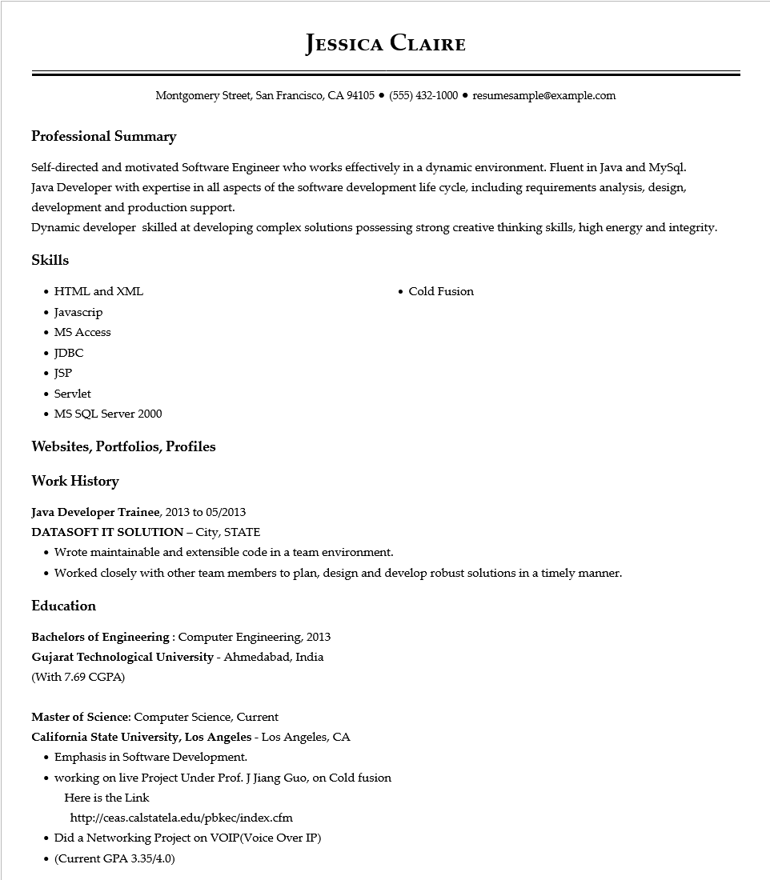
JESSICA CLAIRE
Montgomery Street, San Francisco, CA 94105 ● (555) 432-1000⚫ resumesample@example.com
Professional Summary
Self-directed and motivated Software Engineer who works effectively in a dynamic environment. Fluent in Java and MySql. Java Developer with expertise in all aspects of the software development life cycle, including requirements analysis, design, development and production support.
Dynamic developer skilled at developing complex solutions possessing strong creative thinking skills, high energy and integrity.
Skills
• HTML and XML
• Javascrip
• MS Access
• JDBC
• Cold Fusion
• JSP
• Servlet
• MS SQL Server 2000
Websites, Portfolios, Profiles
Work History
Java Developer Trainee, 2013 to 05/2013
DATASOFT IT SOLUTION - City, STATE
• Wrote maintainable and extensible code in a team environment.
• Worked closely with other team members to plan, design and develop robust solutions in a timely manner.
Education
Bachelors of Engineering: Computer Engineering, 2013
Gujarat Technological University - Ahmedabad, India
(With 7.69 CGPA)
Master of Science: Computer Science, Current
California State University, Los Angeles - Los Angeles, CA
• Emphasis in Software Development.
• working on live Project Under Prof. J Jiang Guo, on Cold fusion Here is the Link
http://ceas.calstatela.edu/pbkec/index.cfm
• Did a Networking Project on VOIP (Voice Over IP)
⚫ (Current GPA 3.35/4.0)

